Grand Plains Police Department

Date: 1/20/23
Subject: Mishandled Digital Evidence
To: Captain Goode
From: Andrew Koenig, Investigative Specialist
It’s important that digital evidence be handled with the same care as physical evidence when dealing with a case. Digital evidence can be tricky to handle as it has become more prevalent in cases today. An example of a situation where evidence may have been mishandled would be the case against Ross Ulbricht, the creator of The Silk Road. The Silk Road was an online black market on the darknet. This market wasn’t findable with a normal web browser, you needed a special browser called the Tor browser to access it. This market hosted all kinds of deals, most of which being drug sales. In October of 2013, the online market was taken down and Ross Ulbricht was arrested as suspect of being the sites creator.
When Ulbricht was arrested, his laptop was also taken into possession. This laptop was allegedly mishandled in a few different was, as explained in the testimony by the Federal agents involved in the arrest. Because of this, two Federal agents were put behind bars on charges of extortion and fraud during the investigation. It was found that he database for the Silk Road forum was tampered with, in order to delete certain communications and information. It is thought that the information deleted was linked to a corrupt law enforcement officer, but this was not proven.
When referencing Reliability and Authenticity of evidence in the Casey text, one could argue that the evidence provided in Ulbricht’s didn’t have either of these. One of the agents responsible for the arrest testified that the evidence being used in court was screenshots of a copy, of a copy. On top of that, the original hard drive from the laptop was described as “a brick that we couldn’t actually look at”.
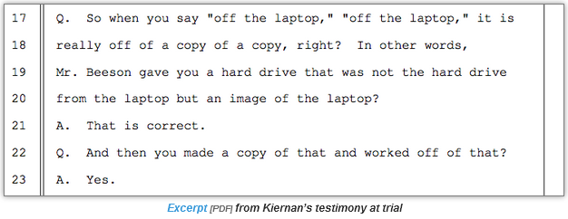

O'Neill, Patrick Howell. “Silk Road Defendant's Lawyers Say Case Has Evidence Tampering and More Corruption.” CyberScoop, 29 Nov. 2016, https://www.cyberscoop.com/evidence-tampered-corrupt-cops-still-free-silk-road-defense-argues/.
“Computer Forensics Critical in the Trial of Silk Road's Ross Ulbricht - HS Today.” Hstoday, 2 Feb. 2015, https://www.hstoday.us/best-practices/computer-forensics-critical-in-the-trial-of-silk-road-s-ross-ulbricht/.

